## Profile

Profiles were converted to csv files, each of which contained an array of distances and an array of corresponding elevations for right and left wheel lines using the ProVAL software. MATLAB was then used to convert the data in the csv file so that it could be directly imported into the LUSAS software for simulation. The custom made Matlab script made the following changes to the data:

* Profile is trimmed to a specified distance before the beginning of the bridge
* Distance values are converted to inches and made to start from 0 at the beginning of the profile
* The profile elevation values, over a specified distance from the profile start, are replaced with linearly increasing/decreasing values so as to provide a “ramp” up to the profile
* New distance and elevation arrays are saved to a text file.

The ramp in the profile data prevents the large initial energy input that would result from a sudden step in the profile. A ramp of 20 feet was specified. The profile was trimmed such that it began 500 feet before the beginning of the bridge, allowing ample time for the vehicle to develop its initial conditions. A sample of the profile for an east-bound right lane is shown below.

## Vehicle model

The vehicle model was developed from the experimental data. The mass of the truck was measured by statically weighing the truck on scales. The acceleration data of the truck was processed using PSD methods and the frequency of the first mode of vibration was determined. Using the relationship for the frequency of a single degree-of-freedom system (w=sqrt(k/m)) the stiffness of the suspension can be determined. Analysis of truck acceleration records show a first mode of vibration at 2.8 Hz. Assuming, 45 kips of the truck weight are carried by the suspension, the suspension stiffness is computed to be 36 kip/in.

While the test truck is more complex than a single degree-of-freedom system, effort was first made to see if this simplification could still yield satisfactory results (i.e. responses similar to what was measured in the field).

Table : Truck Static Wheel Weight Measurements

|  |  |
| --- | --- |
| Passenger Middle | 11680 |
| Passenger Back | 12000 |
| Driver Middle | 12180 |
| Driver Rear | 12080 |
| Total | 47940 |

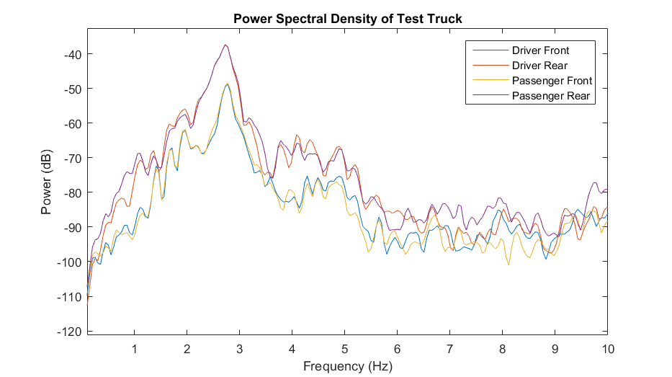

Trials:

Trial 1

|  |  |
| --- | --- |
| Mass | 45 kips |
| Suspension stiffness | 36 k/in |
| Damping | 10% |
| Speed | 715 in/sec |
| Direction/Lane | EB/left |

Trial 2

|  |  |
| --- | --- |
| Mass | 45 kips |
| Suspension stiffness | 36 k/in |
| Damping | 10% |
| Speed | 705 in/sec |
| Direction/Lane | EB/right |

750 in/sec first tried. Results were plotted vs experimental time history. Simulation time vector was scaled until it best seemed to match the experimental data. The inverse of this factor was applied to the specified speed. In this manner, the trial speed was revised to 715 in/sec.

# Results

Test comparison matchups

|  |  |  |
| --- | --- | --- |
| Lane | Run No. | Speed (mph) |
| EB/Left | Run 12, Run 6 | 40, 40 |
| EB/Right | Run 14 | 40 |
| WB/Left | Run 9 | 58 |
| WB/Right | Run 3 | 42 |

Driver rear location was chosen for acceleration comparison

For plots comparing experiment and simulation, data has been filtered such that frequency content greater than 10 Hz is removed to assist with visual comparison. The filtering of the experimental data to remove high frequency content resulted in slightly reduced amplitudes as seen in the image below. The reduction is on the order of 10 to 20% for maximum amplitude. However, as will be shown, the high frequency acceleration does not cause appreciable response in the bridge.

Figure : Filtered and raw experimental truck acceleration data

## Trial 1

The plot comparing the truck acceleration for trial 1 is displayed below. Similar patterns and magnitudes are apparent for the experimental and simulated data. In contrast, the results from simulation with no profile show drastically lower levels of acceleration.

The resulting acceleration of the bridge was also compared in the plot below. The simulated and experimental data for the bridge response share a similar magnitude, confirming that the high frequency content of truck acceleration contributes little to the bridge response, and that the simulation techniques are adequate. It should be noted that the experimental data displayed in the plot below, includes response to traffic that preceded the test truck, and therefore is expected to exhibit a decidedly different time history than the simulation.

Figure : Bridge acceleration at Span 8 (mid-span; girder 5)

Figure : Bridge acceleration at Span 3 (mid-span; girder 5)

Trial 1 was repeated with a different measurement of the profile (i.e. right wheel line, measurement run 2). The results were consistent with the first profile used, thus confirming that the simulation results are relatively insensitive to the minor inconsistencies between profile measurements.

Figure : Truck Acceleration for Different Profile Measurements

Figure : Variation of Measured Profile for a Given Lane

Figure : Comparison of Bridge Acceleration for Different Profiles

## Trial 2

|  |  |
| --- | --- |
| Mass | 45 kips |
| Suspension stiffness | 36 k/in |
| Damping | 10% |
| Speed | 715 in/sec |
| Direction/Lane | EB/right |

715 in/sec also seemed accurate for matching up to run 14.

Right wheel-line profiles better matched experimental results, but there was little difference between measurement runs.

Figure : Comparison of Simulated and Experimental Truck Acceleration (Run 14)

Figure : Comparison of Simulated and Experimental Bridge Acceleration at Span 3

## Trial 3

|  |  |
| --- | --- |
| Mass | 46 kips |
| Unsprung mass | 2 kips |
| Suspension stiffness | 40 k/in |
| Damping | 7% |
| Speed | 715 in/sec |
| Direction/Lane | EB/right |

In an effort to make simulation results better match the experiment, the mass, stiffness and damping of the vehicle model was the adjusted, until a better fit was acquired. Damping ratios of 5, 7, 10 and 20 percent were investigated. Mass and stiffness were increased (while maintaining 2.9 Hz frequency) but they were ultimately bounded by the field measurements, and therefore, were relatively certain parameters. Increased stiffness minimally increased truck acceleration, while decreased damping significantly increased truck acceleration. A truck model with the parameters listed in the table above ultimately resulted truck acceleration that best matched the experimental data.

## Trial 4

|  |  |
| --- | --- |
| Mass | 46 kips |
| Unsprung mass | 2 kips |
| Suspension stiffness | 40 k/in |
| Damping | 7% |
| Speed | 740 in/sec |
| Direction/Lane | WB/right |

Again, the simulation results match the experimental results (for both truck and bridge acceleration).

# Final I76 Simulations

Best comparisons between experimental and simulation for:

East-bound, right lane

Run 14

Simulation details:

|  |  |
| --- | --- |
| Mass | 46 kips |
| Unsprung mass | 2 kips |
| Suspension stiffness | 40 k/in |
| Damping | 7% |
| Speed | 715 in/sec |
| Direction/Lane | EB/right |

Profile: EB_Right_1_R profile

West-bound, right lane

Run 3

Simulation details:

|  |  |
| --- | --- |
| Mass | 46 kips |
| Unsprung mass | 2 kips |
| Suspension stiffness | 40 k/in |
| Damping | 7% |
| Speed | 740 in/sec |
| Direction/Lane | WB/right |

Profile: WB_Right_2_R profile

# Dynamic Amplification

The comparison cases detailed above were used for simulating the dynamic amplification

Run without profile at 2 in/sec (quasi-static)

Run without profile at 715 in/sec

Run with Profile: EB_Right_1_R at 715 in/sec

Recorded the following quantities

* Acceleration of sprung mass
* Force exerted by sprung mass at point of contact
* Bridge responses on exterior girder (8) at midspan for spans 2,3,4,7 & 8
  + Acceleration (Az)
  + Displacement (Dz)
  + Shear Force (Fz)
  + Moment (My)

## Case: East-bound Right Lane

Quasi-static values:

|  |  |  |  |  |  |
| --- | --- | --- | --- | --- | --- |
|  | Span 2 | Span 3 | Span 4 | Span 7 | Span 8 |
| Midspan Deflection (in) | -0.20732 | -0.18124 | -0.1812 | -0.18169 | -0.1817 |
| Midspan Moment | -1310830 | -984383 | -991138 | -985733 | -993041 |
| Midspan Shear Force | 77.6361 | 1189.36 | 1171.92 | 1202.07 | 1161.8 |
| Contact Force | 48 kips |  |  |  |  |

These values are considered the static response when computing dynamic amplification factors.

Dynamic amplification factors at 715 in/sec with no profile:

|  |  |  |  |  |  |
| --- | --- | --- | --- | --- | --- |
|  | Span 2 | Span 3 | Span 4 | Span 7 | Span 8 |
| Midspan Deflection | 1.032736 | 1.034915 | 0.998113 | 1.028324 | 0.999659 |
| Midspan Moment | 1.031675 | 1.030717 | 0.99979 | 1.024801 | 1.000474 |
| Midspan Shear Force | 1.144864 | 1.049094 | 1.04467 | 1.053291 | 1.049397 |
| Contact Force | 1.02 |  |  |  |  |

Dynamic amplification factors at 715 in/sec with profile EB_Right_1_R profile:

|  |  |  |  |  |  |
| --- | --- | --- | --- | --- | --- |
|  | Span 2 | Span 3 | Span 4 | Span 7 | Span 8 |
| Midspan Deflection | 1.860923 | 2.006174 | 2.175542 | 1.975777 | 2.508016 |
| Midspan Moment | 1.854924 | 1.979423 | 2.065696 | 1.965705 | 2.443514 |
| Midspan Shear Force | 3.331053 | 2.407715 | 2.285958 | 2.385227 | 2.324488 |
| Contact Force | 1.80 |  |  |  |  |

## Case: West-bound Right Lane

Run without profile at 2 in/sec (quasi-static)

Run without profile at 740 in/sec

Run with Profile: WB_Right_2_R at 715 in/sec

Quasi-static values:

|  |  |  |  |  |  |
| --- | --- | --- | --- | --- | --- |
|  | Span 2 | Span 3 | Span 4 | Span 7 | Span 8 |
| Midspan Deflection (in) | -0.20645 | -0.18122 | -0.18117 | -0.18169 | -0.1817 |
| Midspan Moment | -1304270 | -984393 | -990995 | -985682 | -992994 |
| Midspan Shear Force | 92.1443 | 1187.05 | 1171.04 | 1202.8 | 1160.98 |
| Contact Force | 48 kips |  |  |  |  |

These values are considered the static response when computing dynamic amplification factors.

Dynamic amplification factors at 740 in/sec with no profile:

|  |  |  |  |  |  |
| --- | --- | --- | --- | --- | --- |
|  | Span 2 | Span 3 | Span 4 | Span 7 | Span 8 |
| Midspan Deflection (in) | 1.03 | 1.01 | 1.03 | 1.01 | 1.02 |
| Midspan Moment | 1.03 | 1.01 | 1.02 | 1.01 | 1.02 |
| Midspan Shear Force | 1.02 | 1.05 | 1.00 | 1.01 | 1.00 |
| Contact Force | 1.01 |  |  |  |  |

Dynamic amplification factors at 740 in/sec with profile WB_Right_2_R profile:

|  |  |  |  |  |  |
| --- | --- | --- | --- | --- | --- |
|  | Span 2 | Span 3 | Span 4 | Span 7 | Span 8 |
| Midspan Deflection (in) | 1.11 | 1.94 | 1.60 | 1.64 | 1.32 |
| Midspan Moment | 1.12 | 1.89 | 1.59 | 1.60 | 1.32 |
| Midspan Shear Force | 1.42 | 1.94 | 1.68 | 1.57 | 1.47 |
| Contact Force | 1.68 |  |  |  |  |